PRACTICAL – 1

PROGRAM -1

AIM- TO FIND THE SUM OF TWO NUMBER WITHOUT INPUT FROM USER

CODE-

#include<stdio.h>

main()

{

printf("HARSH D");

int a,b,ans;

a=5;

b=6;

ans=a+b;

printf("\n Sum of two digit = %d",ans);

}

OUTPUT-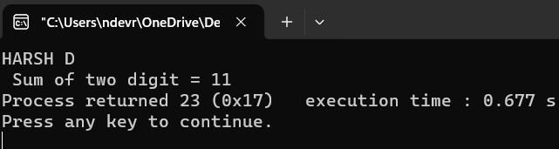

PROGRAM -2

AIM- WRITE A C PROGRAM TO USE OF CONSTANT KEYWORD

CODE-

#include<stdio.h>

int main()

{

printf("HARSH D");

const int LENGTH = 10;

const int WIDTH = 5;

int area;

area=LENGTH*WIDTH;

printf("\n Area = %d",area);

return 0;

}

OUTPUT:-

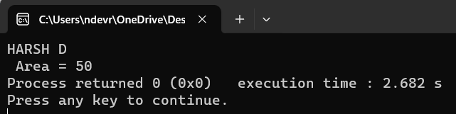

PROGRAM -3

AIM- WRITE A C PROGRAM USING ASSINGMENT OPERATOR

CODE-

#include<stdio.h>

main()

{

printf("\n HARSH D \n");

int x,y;

printf("\n Enter Value of Variable 1 = ");

scanf("%d",&x);

printf("\n Enter Value of Variable 2 = ");

scanf("%d",&y);

x+=y;

printf("\n SUM = %d",x);

x-=y;

printf("\n SUBTRACTION = %d",x);

x*=y;

printf("\n MULTIPLICATION = %d",x);

x/=y;

printf("\n DIVISION = %d",x);

x%=y;

printf("\n MODOLOUS = %d",x);

printf("\n");

y+=x;

printf("\n SUM = %d",y);

y-=x;

printf("\n SUBTRACTION = %d",y);

y*=x;

printf("\n MULTIPLICATION = %d",y);

y/=x;

printf("\n DIVISION = %d",y);

y%=x;

printf("\n MODOLOUS = %d",y);

}

OUTPUT:- 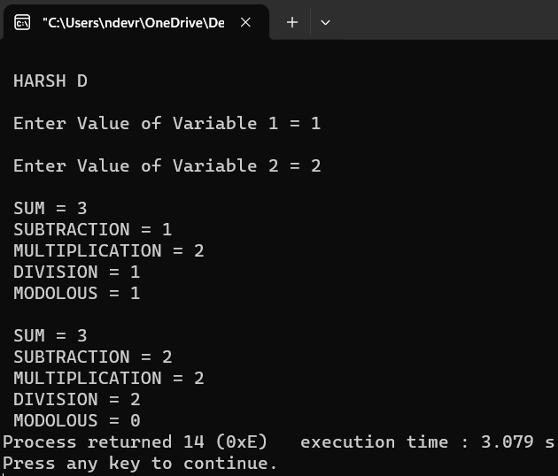

PROGRAM -4

AIM- WRITE A C PROGRAM USING INPUT FROM THE USER AND FIND OUT THE GIVEN NUMBER IS EVEN OR ODD [ USING CONDITIONAL OPERATOR ]

CODE-

#include<stdio.h>

void main()

{

int a;

printf("\n HARSH D \n");

printf("Enter Value = ");

scanf("%d",&a);

(a%2==0)?printf("%d is Even Number",a):printf("%d is Odd Number");

return 0;

}

OUTPUT:-

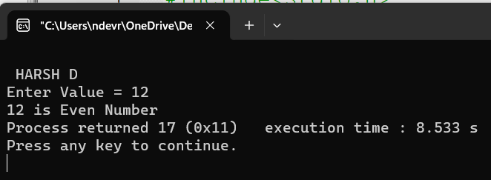

PROGRAM -5

AIM- BITWIZE OPERATOR (AND)

CODE-

(AND)=

#include<stdio.h>

void main()

{

printf("\n HARSH D \n");

int a=12;

int b=25;

int c=a&b;

printf("Output = %d",c);

return 0;

}

OUTPUT:-

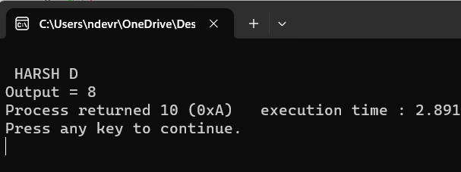

AIM- BITWIZE OPERATOR [OR],{XOR}

CODE- OUTPUT:-

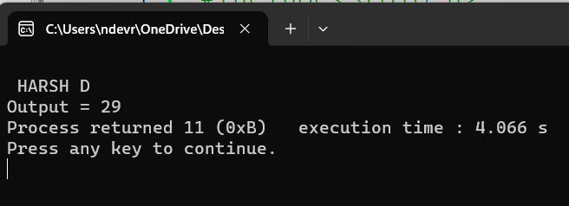[OR]=

#include<stdio.h>

void main()

{

printf("\n HARSH D \n");

int a=12;

int b=25;

int c=a|b;

printf("Output = %d",c);

return 0;

}

CODE:- OUTPUT:-

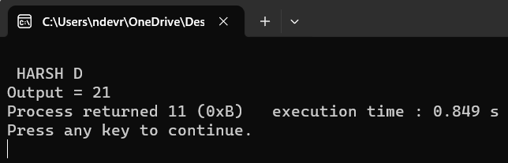{XOR}=

#include<stdio.h>

void main()

{

printf("\n HARSH D \n");

int a=12;

int b=25;

int c=a^b;

printf("Output = %d",c);

return 0;

}

PROGRAM -6

AIM- Increment_Operator[With both post and pre](With ,input from user).c

CODE- OUTPUT:-

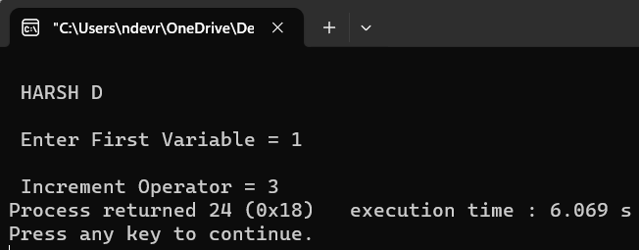#include<stdio.h>

main()

{

printf("\n HARSH D \n");

int x;

printf("\n Enter First Variable = ");

scanf("%d",&x);

x++; /*POST INCREMENT */

++x; /*PRE INCREMENT */

printf("\n Increment Operator = %d",x);

}

AIM- Increment_Operator[With both post and pre].c

CODE:- OUTPUT:-

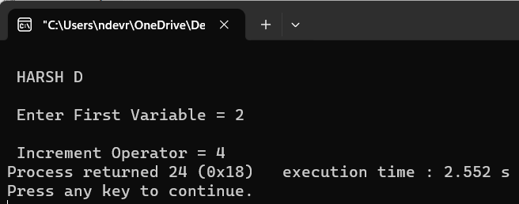#include<stdio.h>

main()

{

printf("\n HARSH D \n");

int x;

printf("\n Enter First Variable = ");

scanf("%d",&x);

x++; /*POST INCREMENT */

++x; /*PRE INCREMENT */

printf("\n Increment Operator = %d",x);

}

AIM:- Drecrement_Operator[With both post and pre](With ,input from user).c

CODE:- OUTPUT:-

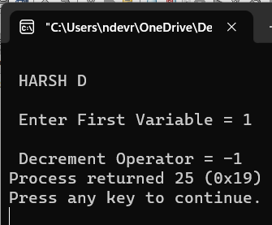#include<stdio.h>

main()

{

printf("\n HARSH D \n");

int x;

printf("\n Enter First Variable = ");

scanf("%d",&x);

x--; /*POST DRECREMENT */

--x; /*PRE DECREMENT */

printf("\n Decrement Operator = %d",x);

}

AIM:- Drecrement_Operator[With both post and pre].c

CODE:- OUTPUT:-

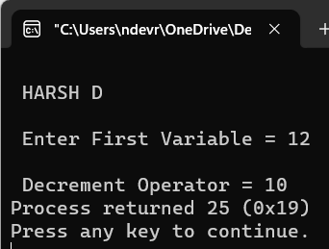#include<stdio.h>

main()

{

printf("\n HARSH D \n");

int x;

printf("\n Enter First Variable = ");

scanf("%d",&x);

x--; /*POST DRECREMENT */

--x; /*PRE DECREMENT */

printf("\n Decrement Operator = %d",x);

}

PROGRAM -7

AIM- LEFT SHIFT

CODE- OUTPUT:-

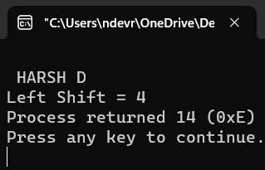# #include<stdio.h>

void main()

{

printf("\n HARSH D \n");

int a = 8,b;

b= a >> 1;

printf("Left Shift = %d",b);

}

AIM- RIGHT SHIFT

CODE- OUTPUT:-

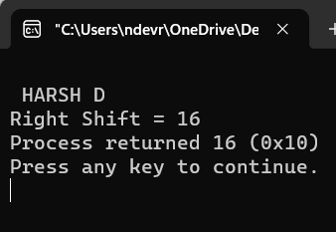#include<stdio.h>

void main()

{

printf("\n HARSH D \n");

int a = 8,b;

b= a << 1;

printf("Right Shift = %d",b);

}

PROGRAM -8

AIM- WRITE A C PROGRAM FOR IMPLICIT CONVERSION

[WITHOUT INPUT FROM USER]

CODE-

#include<stdio.h>

void main()

{

printf("\n HARSH D \n");

int a =5;

char b ='A'; /* A= AISCC VALUE = 65 SO answer will be 65+5=70*/

int c =a+b;

printf("Answer of Implicit Type Conversion = %d",c);

return 0;

}

OUTPUT:-

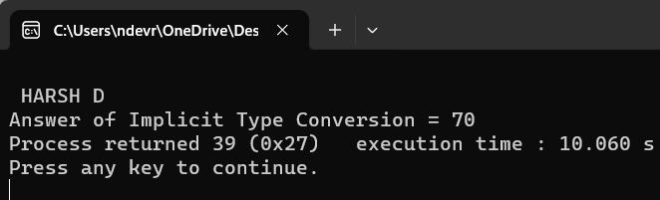

PROGRAM -9

AIM- WRITE A C PROGRAM FOR EXPLICIT CONVERSION

[WITHOUT INPUT FROM USER]

CODE-

#include<stdio.h>

void main()

{

printf("\n HARSH D \n");

double a = 1.2;

int b=5;

float c=b+(float)a;

printf("The Value Of Explicit Conversion = %f",c);

}

OUTPUT:-

